1. Create a collection by name Customers with the following attributes.

Cust_id, Acc_Bal, Acc_Type

db.createCollection("Customer");

2. Insert at least 5 values into the table

db.Customer.insertMany([{custid: 1, acc_bal:10000, acc_type:

"Saving"}, {custid: 1, acc_bal:20000, acc_type: "Checking"}, {custid: 3,

acc_bal:50000, acc_type: "Checking"}, {custid: 4, acc_bal:10000,

acc_type: "Saving"}, {custid: 5, acc_bal:2000, acc_type: "Checking"}]);

3. Write a query to display those records whose total account balance is greater than

1200 of account type ‘Z’ for each customer_id.

db.Customer.find({acc_bal: {$gt: 12000}, acc_type:"Checking"});

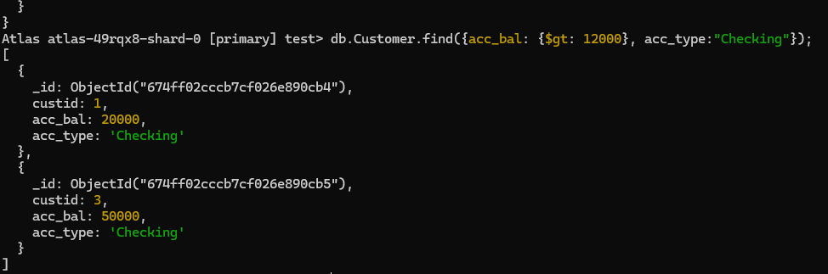

4. Determine Minimum and Maximum account balance for each customer_id.

db.Customer.aggregate([{$group:{_id:"$custid", minBal:{$min:"$acc_bal"}, maxBal:

{$max:"$acc_bal"}}}]);

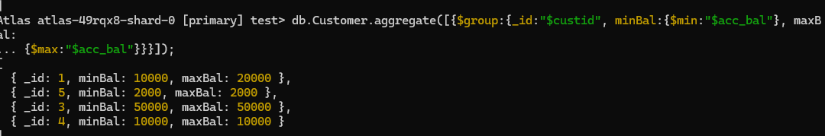

5. Export the created collection

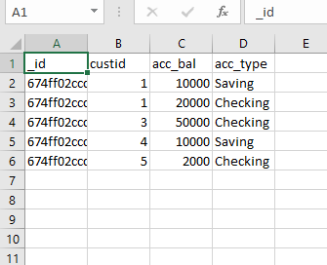

6. Drop the table

Db.Customer.drop();